Payroll Management System for Information Technology Company

Version 1.0

Revision History

|  |  |  |  |
| --- | --- | --- | --- |
| **Date** | **Version** | **Description** | **Author** |
| 31/10/2019 | 1.0 | Final | Ta Van Hiep |
|  |  |  |  |
|  |  |  |  |
|  |  |  |  |

Table of Contents

1. Updating Feedback 4

1.1 Brief Description 4

1.2 Actor Adminstrator. 4

2. Flow of Events 4

2.1 Basic Flow 4

3. Special Requirements 5

4. Precondition 5

5. Postconditions 5

6. Extension Points 5

ary

# Updating Feedback

## Brief Description

This use case defines steps of updating a salary of employee in the system. Administrator

easily update a salary in the database.

## Actor Administrator.

# Flow of Events

## Basic Flow

The system administratorsearch and select salary to modify and change information such as bonus, date. Then, accountant or employee update information. All information is updated management such as OT, bonus. role salary, deduction. Then, system will calculate and show total salary after update. Finally, to make sure to success click update.

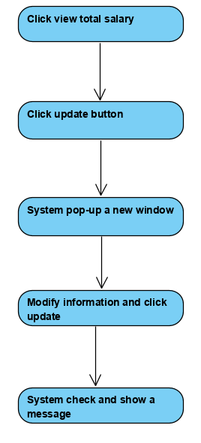



Basic flow of Updating Department

# Special Requirements

No special requirements

# Precondition

Login.

# Postconditions

No postconditions.

# Extension Points

No extension points.